Part 1 - Create and Deploy Customized WebApplication (Javascript Webite)

Step 1: Create Elastic Beanstalk Web Application

Deploy using Tomcat 7 w/ Java 7

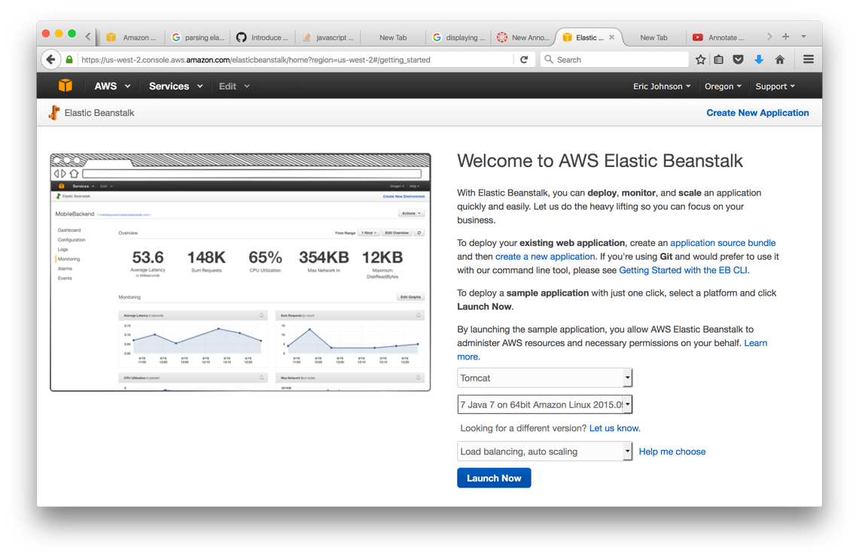

Step 2: Customize and Upload Javascript Website

Part 2 - Create and Deploy ElasticSearch Index on Twitter Live Streaming

Following a guide on how to install ElasticSearch I first launch a Ubuntu Instance of AWS EC2 and then configured the EC2 instance to be accessible from my Elastic Beanstalk WebApplication. Once I had the ElasticSearch index running on my EC2 instance I installed Tweepy and configured a Python script called Twitter_Tweepy.py (included in submission) to create a Twitter LIve Monitoring thread and save the results to my ElasticSearch index.

Once the Twitter LiveMonitoring stream was created an populating my ElasticSearch index it was just a matter of querying an parsing the JSON results for each of my keywords in the Javascript portion of my Elastic Beanstalk WebApplication.

Installation: ElasticSearch

Installation: Tweepy

Python Script: Twitter Live Streaming -> ElasticSearch